TASK 4
- Average Grade by Gender
SELECT
s.Gender,
ROUND(AVG(e.Grade), 2) AS AvgGrade
FROM Enrollments e
JOIN Students s ON e.StudentID = s.StudentID
GROUP BY s.Gender;

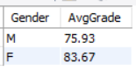

2. Pass Rate per Course (Grade ≥ 40)
SELECT
c.CourseName,
ROUND(
SUM(CASE WHEN e.Grade >= 40 THEN 1 ELSE 0 END) * 100.0 / COUNT(*),2 ) AS PassRate
FROM Enrollments e
JOIN Courses c ON e.CourseID = c.CourseID
GROUP BY c.CourseName;
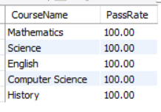
3.Top 3 Students Overall (Based on Average Grade)

SELECT
s.Name AS StudentName,
ROUND(AVG(e.Grade), 2) AS AvgGrade
FROM Enrollments e
JOIN Students s ON e.StudentID = s.StudentID
GROUP BY s.StudentID, s.Name
ORDER BY AvgGrade DESC
LIMIT 3;
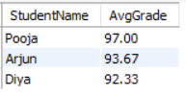
4. Students in More Than 2 Courses
SELECT
s.Name AS StudentName,
COUNT(e.CourseID) AS TotalCourses
FROM Enrollments e
JOIN Students s ON e.StudentID = s.StudentID
GROUP BY s.StudentID, s.Name
HAVING COUNT(e.CourseID) > 2;
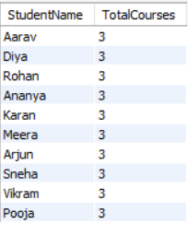
This task focuses on generating analytical reports using SQL.
It includes gender-based performance analysis, course-wise pass rates, top-performing students, and multi-course enrollments.
Advanced queries using JOIN, GROUP BY, HAVING, and conditional aggregation were implemented.

